**Online Advertising with Decision Making Algorithms**

Risk Takers Group

Benjamin Ashton

Spencer Lingwall

Final Scientific/Technical Report

**Task Summary**

| **Proposal** | Spencer Lingwall |
| --- | --- |
| **Explore and Exploit** | Benjamin Ashton |
| **Monte-Carlo** | Spencer Lingwall |
| **Game Theory** | Spencer Lingwall |
| **Report** | Benjamin Ashton / Spencer Lingwall |

**Public Executive Summary**

This project simulates some real world situations for online advertising that will help companies choose the best advertising space and strategies for them. It compares click through rates of various spaces and selects the best option, it estimates the approximate potential value of an advertising space for the company, and it compares a few different strategies for competing with different companies for advertising spaces. For a young startup company, they would be able to tailor the algorithms to their situation and use it to select the best online advertising space and strategy for them.

From our default settings with a $25 product we found that Google’s Search Advertising space ended up being the best valued with a competitive bidding strategy.

**Acknowledgements**

Information about the Algorithms was taught by Dr. Mario Harper a professor at Utah State University. Example data that we used to create valid simulations were from statista.com and various datasets on kaggle.com.

**Accomplishments and Objectives**

Our goal was to create tools to help companies decide on how they should advertise their products and where. We wanted to show the best platforms for advertising and what might be the best option for them. These goals were largely met by demonstrating which advertising spaces ended up with the highest value and best click through rates. Additionally we gave insight into how different bidding strategies on spaces might work best over the course of time.

A number of tasks and milestones were laid out at the beginning of the project. The actual performance against the stated milestones is summarized here:

**Table 1. Key Milestones and Deliverables.**

| **Tasks** | **Milestones and Deliverables** |
| --- | --- |
| **Task 1: Learning/ Proposal**  1.1 Learn about different strategies and spaces.  1.2 Revise plans based on proposal feedback. | Q1: Create Project Proposal  **Actual Performance:** (April 11) Proposal Finished on time. Strategies we decided to use were Explore and Exploit, a Monte Carlo Algorithm and Game Theory.  Q2: Revise Plan if needed.  **Actual Performance:** (April 18) Project Revised to include more accurate Data from various datasets. This helps to make simulations more accurate. |
|
|
|
|
|
|
|
|
|
|
|
| **Task 2: Explore and Exploit**  2.1 Write Algorithm  2.2 Collect Data  2.3 Simulate Data | Q1: Complete Development for an Explore and Exploit Algorithm  **Actual Performance:** (April 25th) Collecting data for this algorithm and then simulating it was the most difficult part of this task. Project completed and simulations resulted in selecting Google Search as the most user interactive advertising space. |
| **Task 3: Monte Carlo**  2.1 Write Algorithm  2.2 Collect Data  2.3 Simulate Data | Q1: Complete Development for a Monte Carlo Algorithm  **Actual Performance:** (April 24th) Creating a definition for the value of the algorithm was most difficult. We used a dynamic value that could be changed based on the product revenue the company might be selling in the space. This tailors the algorithm to a specific company. |
| **Task 4: Game Theory**  2.1 Write Algorithm  2.2 Collect Data  2.3 Simulate Data | Q1: Complete Development for a Game Theory simulation.  **Actual Performance:** (April 25th) We Choose three different bidding strategies for this simulation. Standard (Passive), Bidder (Aggressive), and Hunter (Maximizing). From these the bidder tended to do the best unless the hunter got lucky early on and didn’t run into competition with another bidder. |
| **Task 4: Cleanup**  2.1 Clean Code  2.2 Compile README  2.3 Write Report | Q1: Cleanup Code.  **Actual Performance:** (April 26th) Removed extra lines of code and extra imports. Added Requirements into README file.  Q2: Put Documents Together  **Actual Performance:** (April 28th) Revision of documents completed and notes about simulations added into the project report. |

Results were not Peer-reviewed as this is primarily a demonstration of simulations a company can use to run against its own data. We used public data to imitate what a simulation for a typical company might look like.

**Project Activities**

The project’s main focus was to demonstrate how decision making algorithms can give information to companies regarding how they should approach online advertising spaces. It shows which spaces have the best click through rate and which spaces might be most valuable. It also demonstrates what strategies might be best to use for a company to out bid other competitors.

**Project Outputs**

***A. Description of Code***

Simulations are run using UserResponse.py, AdvertisingSpace.py, and AdvertisementCompetitors.py. See README.md file for more information regarding requirements for running each of these simulations.

***B.*** ***Expected Outcomes of Running Code***

UserResponse.py should result in graphs that show the algorithm selecting the best advertising space for user interactions. It is based on click through data found on agencyanalytics.com. From this simulation we expect one advertising space to be favored from the group which yields the best click through rate. With this part of the project, we should be able to show the benefit of using an explore and exploit algorithm in deciding on an internet advertising strategy.

AdvertisingSpace.py should result in demonstrating how profitable an advertising space may be given a revenue from a product and how well the click through rate might be. Additionally it will take the click to-buyer rate that is largely determined by the seller and their website. From this we should be able to determine an advertising space that would be best for a company.

AdvertisimentCompetitors.py should reveal how a company should strategize against another competitor. We expect that outbidding the other company should be the best strategy, along with seeking out the most valuable spaces. We will compare three strategies: Standard, Bidder, and Hunter to see which strategy might yield the best results. The Standard strategy will share the revenue equally between all other standard competitors. The Bidder will take all the revenue from any Standard competitor while paying more for the fought over space. They will share the value between other bidders equally but still pay the extra for trying to outbid their competitor. Hunters will seek out the best valued spaces first and then follow the bidder strategy. We expect the Hunter to do the best.

***C.*** ***Results***

UserResponse.py resulted in the algorithm selecting Google Search advertising space as having the best user interactions. The simulations ended up with an average click through rate of around 3.

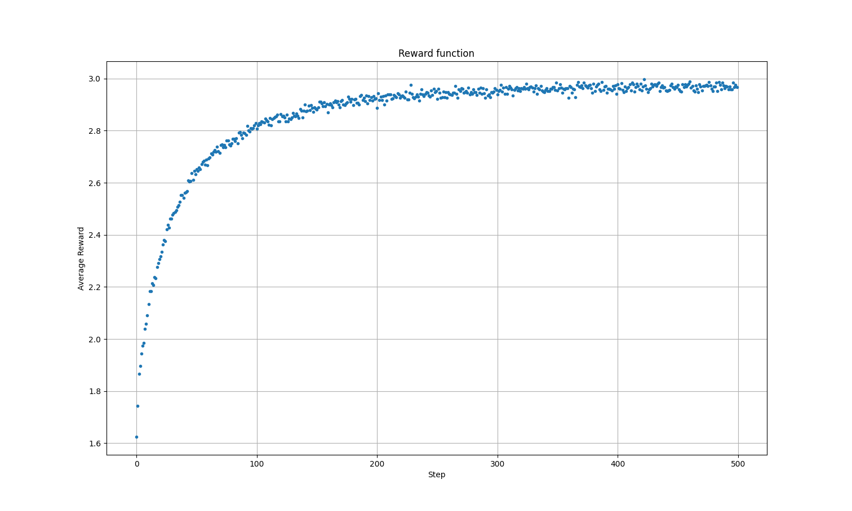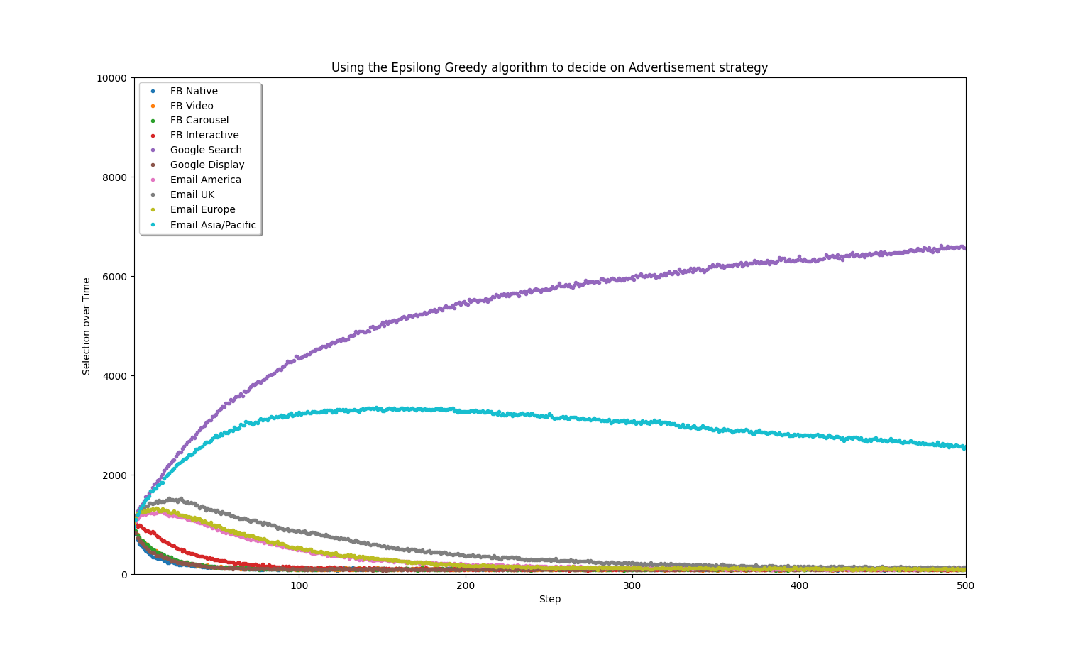

The above images demonstrate the average reward from the algorithm selecting various advertising spaces. The best ended up being Google Search followed by Email in the Asia/Pacific area. They also show the effectiveness of using an Epsilon-Greedy algorithm when deciding on which internet advertising strategy to use.

AdvertisingSpace.py resulted in many different paths for various spaces. The overall lesson was the more revenue the product made, the higher value any given advertising space was. For a product that made $25, only Google and Youtube based advertising spaces yielded positive results. This is largely due to their cheap prices for advertising.

The worst space for advertising that we simulated was Tik Tok which charges per view rather than per click. This resulted in negative profit up until the product was making over $100 in revenue.

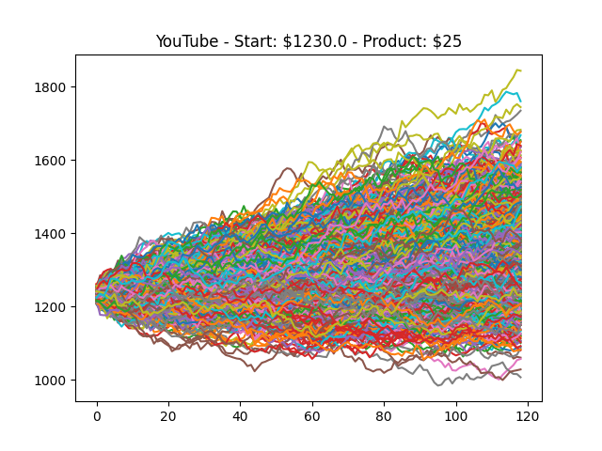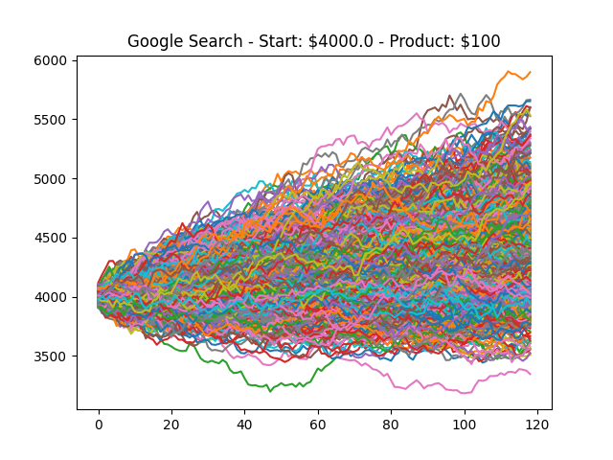

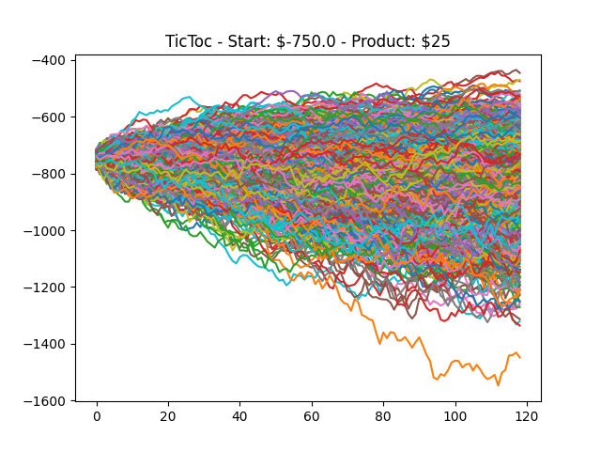

AdvertisimentCompetitors.py resulted in several different outcomes. The important lesson we learned from simulating these strategies is that it is important to advertise in the best spaces early and outbid your competitor. However, the best spaces change when a competitor also selects that space. The best space at the beginning is a space that is not occupied and has the highest value.

We set each space at a price of $1 and then had the option to randomly vary the space’s return value or keep it stable at $2. We then measured the companies’ budgets and compared them to each other. We elected to remove any extra dollars not spent at the end of selecting spaces to keep things more finite and measurable. The strategies we used were Standard, Bidder, and Hunter. Standard would

With varying prices, it became important to select the highest value spots when there were more than 2 competitors using the passive strategy. Companies that survived were those lucky enough to have a high enough return to expand quicker. Once a ‘bidder’ was introduced, the passive model became rather worthless. Bidders were able to compete with each other however when a hunter became involved, the Hunter dominated most often. This was not always the case however as if the hunter selected a space early on that was occupied by another bidder, this would allow another bidder to gain value quicker and end with the hunter bankrupting fast. Typically, this was not the case, but a few simulations resulted in this which makes it important to mention.

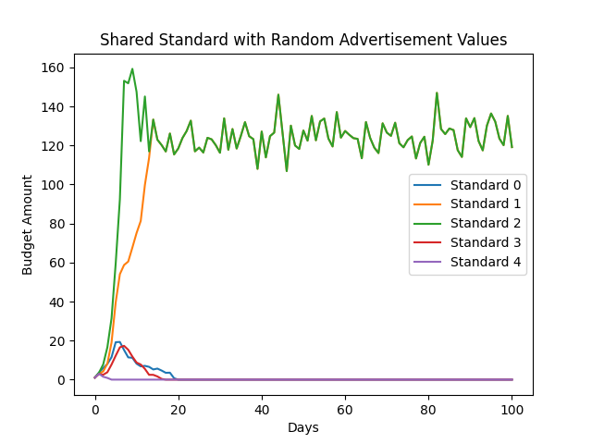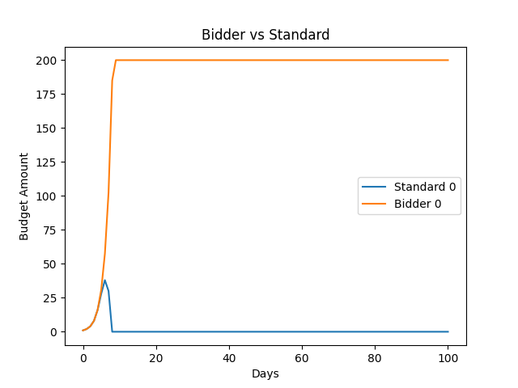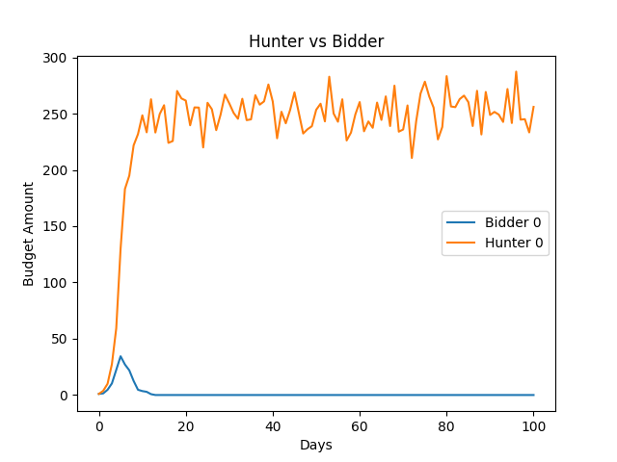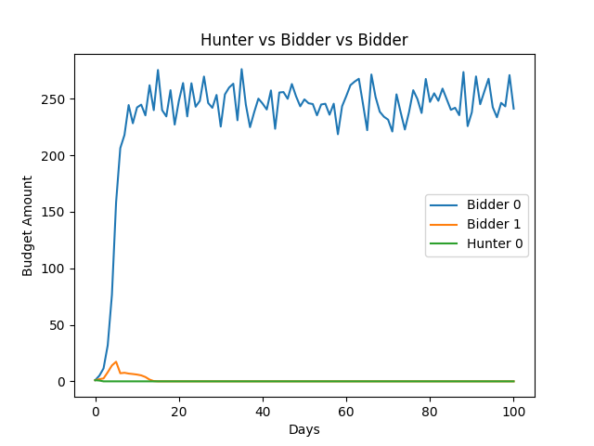

Our conclusion from these results is to choose the best value early unless another competitor has already selected that option. Then after you have saturated your budget, outbid all other competitors.

***D.*** ***Conclusions***

From running each of these simulations we found that a typical startup company should advertise using the Google Display or Google Search ads first before expanding to other advertising spaces. They should then compete for better visibility with their competitors once they have a foothold. However, it would be preferred if the company runs these simulations themselves with data they collected through trying out different advertising strategies. This will result in the best outcome for the company.